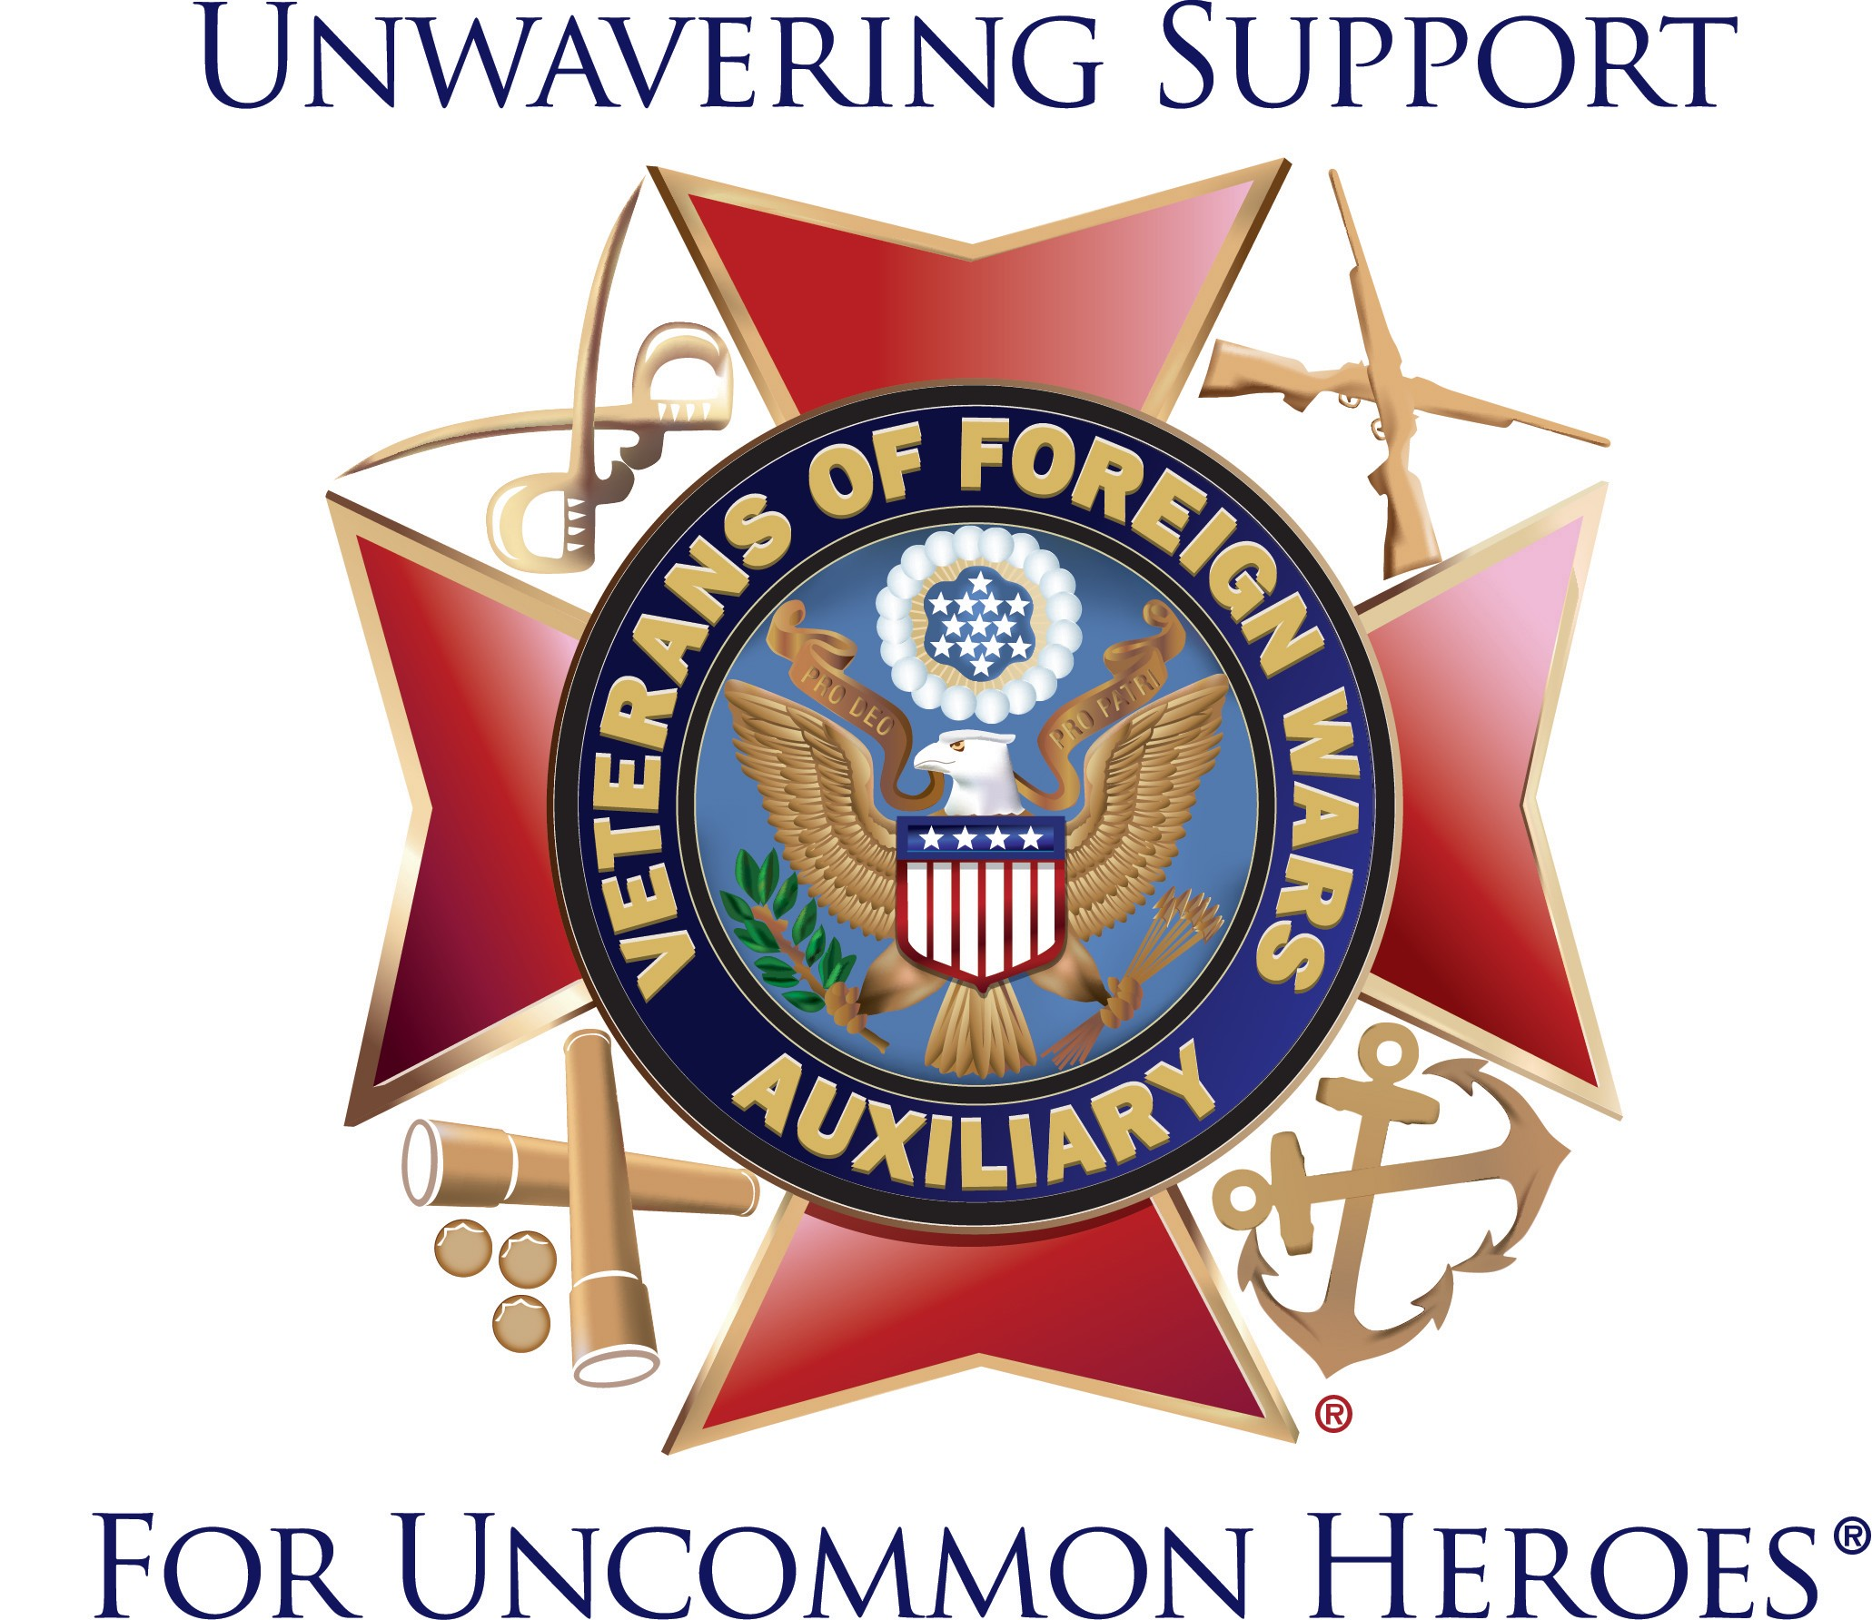

VETERANS OF FOREIGN WARS AUXILIARY

POST # [ENTER POST NUMBER]

For more information, contact: Email:
Phone:

MEDIA RELEASE

FOR IMMEDIATE RELEASE

VFW AUXILIARY FORMING IN [ENTER CITY and STATE] WILL WORK TO IMPROVE THE LIVES OF VETERANS AND THEIR FAMILIES IN OUR COMMUNITY

Male and female relatives of those who served in overseas combat have an opportunity to join the nation’s oldest Veterans Service Organization Auxiliary and work to improve the lives of veterans and their families in our community.
A new VFW Auxiliary is in the process of forming in [ENTER CITY and STATE] is inviting relatives of those who served in overseas combat to join them and a network of more than 3,600 Auxiliaries and nearly 470,000 members nationwide in enhancing our community through volunteer projects, patriotic programs, youth scholarships, and activities that support veterans, service members and their families.

The VFW Auxiliary has served veterans, service members and their families for more than 100 years. Members provide assistance to veterans and their families, work to instill patriotism in youth, provide countless hours of service in the VA and other medical facilities, and make sure their support of veterans issues is heard on Capitol Hill.
For information on joining the forming Auxiliary, or ways to work with the Auxiliary in [ENTER CITY and STATE] contact [CONTACT NAME] at [CONTACT PHONE and/or EMAIL]

-MORE-

The VFW Auxiliary is one of the nation’s oldest veterans’ service organizations and our members are the relatives of those who served in a location of foreign conflict. We have nearly 470,000 members representing all 50 states who volunteer millions of hours and give millions of dollars to support veterans, military service personnel, and their families.

We are a voice for veterans on Capitol Hill and are instrumental in assisting the VFW pass or block legislation that impacts veterans and their families. We are one of the top 10 providers of volunteer hours in the VA medical system. Every year, members fundraise millions of dollars for charitable projects that benefit veterans and their families. We also provide hundreds of thousands of dollars in scholarships for our nation’s youth. With more than 3,600 Auxiliaries, there is likely one in your area working to improve the lives of America’s uncommon heroes. Learn more at www.vfwauxiliary.org.

###

